Rotary Club of Kathmandu Mid-Town
Breakfast Chatter




20 January 2012 The Weekly Bulletin of Rotary Club of Kathmandu Mid-Town Bc-1.20/011-12

District: 3292 Web: www.rotarymidtown.org.np Club Id : 26776

JANUARY IS THE ROTARY AWARENESS MONTH
Awareness is an important part of the Rotary work that can be divided into two parts.
It is imperative that members are well aware of Rotary’s goals – that Rotary is an organization that works for peace and better understanding between people.
The other part of Rotary awareness is the sharing of information outside of our organization.

13 January, Friday:
Suvani Singh, Organizer, Kathmandu Literary Jatra, was our guest speaker for the day.
Kathmandu Literary Jatra was organized from 16-18 Sep, 2011 at Patan Museum, Lalitpur, Nepal.
The organizing venue is enlisted as world heritage site by UNESCO. The festival's objective was to provide a platform for literature from Nepal to engage with its international counterpart and to take Nepali literature on to the global stage.
Various discussion programs were organized during the three-day event to bring common platform for readers and writers. The participants were prominent writers from the country. The event provided them a platform to hold thematic discussions on various topics pertaining to Nepal and South Asia in both socio-political and literary context with the foreign delegates. This program got wide media coverage and was loved by readers. "This kind of program brings writers close to its readers and should be frequently organized", commented one member in audience.
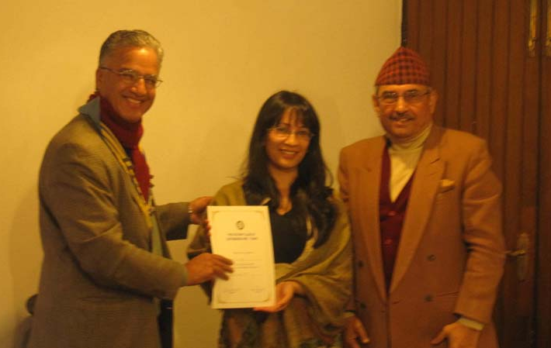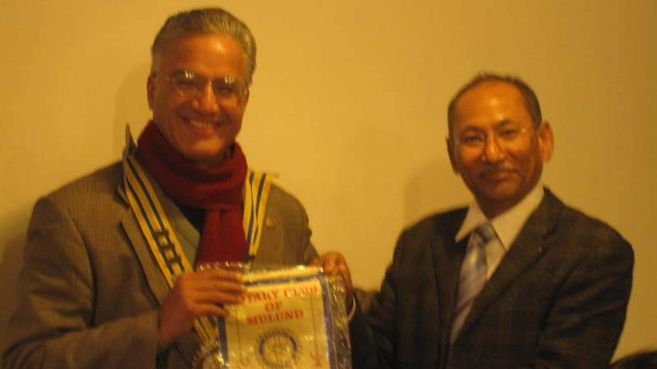
President Som presenting a certificate of appreciation to PP Gopal handing over Club flag of RC Mulund
Guest Speaker Suvani Singh flanked by Rtn KNS Thapa to President Som
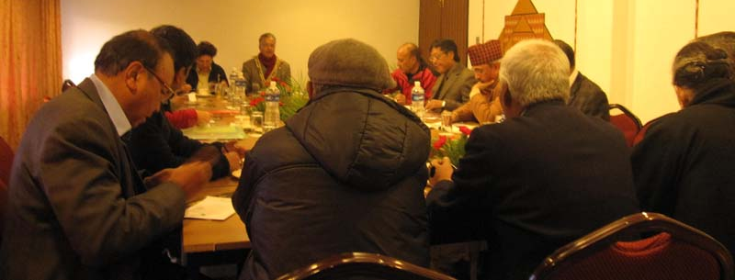
Weekly Meeting in progress

Weekly Meetings and Programs :
Date | Program/Speaker | Program/Topics of Presentation
20 January 2012 | Kamala Sharma, Volunteer's Hand Nepal | Poor orphans
27 January 2012 | Kiran Joshi, CEO of Incessant Rain | Animated films in Nepal

Gorkha-Lamjung Girl Child project :
Program for visiting Gorkha and Lamjung project sites for distribution of student stationeries and school dresses to girl child students, handing over sewing machines for tailoring training, material for candle making training, and seed money for goat farming program:
Departure Kathmandu for Gorkha on Saturday 4 Feb 2012 at 8:00 hrs.
After completion of program in Gorkha, night stay at Bandipur.
Departure Bandipur for Lamjung on Sunday 5 Feb 2012 at 8:00 hrs
After completion of program in Lamjung, set off for Kathmandu;
Arrival Kathmandu at around 19:00 hrs same day.
For further details please contact PP Arun, Chairperson, Service Projects.

RYLA:
RYLA 2012 is scheduled to be held on 3-7 February 2012 at Chetana Kendra (Gramin Training Center) in Dhulikhel, Budol-Kavre. The RYLA is organized for young people of age-group 14-18 years nominated by Rotary clubs. Two rotaracts/interacts from our club will be participating in the up-coming RYLA.

Top five Rotary stories of 2011
From the tsunami in Japan to the launch of strategic partnerships that will help Rotary expand its reach, 2011 was an eventful year for Rotary International and Rotarians. As the year winds down, we share our list of the top five Rotary news events of 2011.
4. 2011 RI Convention
More than 16,000 Rotarians from around the world converged on New Orleans, Louisiana, USA, in May for the 2011 RI Convention. Rotaractors, Rotarians, and Rotary Foundation alumni participated in service projects to help families still recovering from damage caused by Hurricane Katrina in 2005.
Among the highlights during four packed days of plenary and breakout sessions was a speech by Bill Gates, cochair of the Bill & Melinda Gates Foundation, in which he praised Rotary for its success in the campaign to eradicate polio and urged Rotarians to redouble their efforts to keep the disease from spreading. Another speaker was Michael McQueen, a leading authority on youth trends, who said Generation Y has much to offer Rotary.
5. Strategic partnerships
The Rotary Foundation Board of Trustees approved four strategic partnerships in 2011 under the Future Vision Plan. These partnerships will help Rotary broaden its impact in the areas of focus by offering service opportunities for Rotarians through packaged global grants.
Rotary clubs will be teaming up with UNESCO-IHE Institute for Water Education to train scientists and engineers to solve problems related to water and sanitation, particularly in developing countries. Grants will support scholarships for master's degree programs at the institute's campus in Delft, the Netherlands.
Through the partnership with Aga Khan University, vocational training teams will enhance the clinical and administrative skills of health educators at the university's campuses in Kenya, Tanzania, and Uganda.
Rotarians will work with Oikocredit International to advance community and economic development through the Netherlands-based cooperative's network of microfinance institutions.
And the partnership with Mercy Ships will enable clubs to get involved in improving health care services in West Africa.
The packaged global grants are available to Future Vision pilot districts and clubs.
Source: Rotary International News

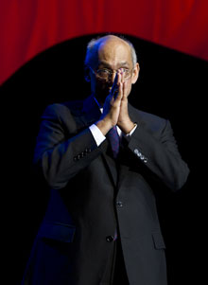
.... And the other area we must look at is telling well the story of Rotary to the world. Too
often do we believe that because we are doing so well, the world must be looking at us.
Well, the world isn’t, for most of the time.
RI President Kalyan Banerjee

On Lighter Side :
Click here ⇩


A thought for the day:
I am thankful to all those who said ‘NO’ to me. It’s because of them I did it myself!
Albert Einstein


Pencil art pieces

Please send project/activity information, suggestions and photos etc to :
BC Editor: RR Shrestha email: rryes@wlink.com.np

20 January 2012 The Weekly Bulletin of Rotary Club of Kathmandu Mid-Town bc-1.20/011-12

